Input Contribution to EACO
Online meeting 17-18 August 2021
Input Contribution XX
10-August-2021
Kenya

Agenda Item 1.3
Part A: Description
In accordance to Resolution 246 (WRC-19) the aim of Agenda Item 1.3 is to conduct “Studies to consider possible allocation of the frequency band 3 600-3 800 MHz to the mobile, except aeronautical mobile service, on a primary basis within Region 1.”
Resolution 246 (WRC-19) resolves to invite the ITU Radiocommunication Sector (ITU-R) to conduct sharing and compatibility studies in time for World Radiocommunication conference 2023 (WRC-23) between the mobile service and other services allocated on a primary basis within the frequency band 3 600-3 800 MHz and adjacent frequency bands in Region 1, as appropriate.
Resolution 246 (WRC-19) recognizes that for African countries, especially those in tropical areas, the operations of FSS systems are more reliable for use in at C-band frequencies (3 400-4 200 MHz), rather than in higher frequency bands.
Resolution 246 (WRC-19) also calls to ensure protection of those services to which the frequency band is allocated on a primary basis and not impose undue constraints on the existing services and their future development.
It is important to note that this agenda item only seeks to upgrade the existing secondary mobile allocation in the frequency band 3 600-3 800 MHz to primary in Region 1.

Part B: Key Elements – the notables
k

However, currently, some administrations in Region 1 especially countries found in European Union are currently using the frequency band 3 600-3 800 MHz, or part of that frequency band, for the mobile service (for example International Mobile Telecommunications (IMT) implementation), which terrestrial systems of the mobile service are intended to provide telecommunication services on a worldwide scale, regardless of location.

Meanwhile, it is necessary to protect existing services when considering possible additional allocation to any service in any frequency band.

WRC-23 agenda item 1.3 is to consider primary allocation of the band 3 600-3 800 MHz to mobile service within Region 1 and take appropriate regulatory actions, in accordance with Resolution 246 (WRC-19). Resolution 246 (WRC-19) resolves to invite the ITU Radiocommunication Sector:

“To conduct sharing and compatibility studies in time for WRC-23 between the mobile service and other service allocated on a primary basis within the frequency band 3 600-3 800 MHz and adjacent frequency bands in Region 1, as appropriate, to ensure protection of those services to which the frequency band is allocated on a primary basis and not impose undue constraints on the existing services and their future development".

Sharing studies, conducted examine the impact of co-channel interference caused by MS systems into the FSS ES operating in the frequency band 3 600-3 800 MHz.
The studies are based on:
(a) existing operational FSS ES;
(b) mobile BSs, which are simulated to operate in the 3600-3800 MHz band; and
(c) actual terrain profile around them.

These studies are based on protection of an FSS ES at a known location and does not address ubiquitous FSS deployment delivering services directly to consumers e.g. direct-to-home (DTH).

This sharing study analyzes possible co-existence between FSS and MS systems in the same band on a co-primary basis and determine the impact from MS on FSS receiving ES.

The results are given in the form of separation distances required to protect the FSS ES from in-band interference caused by a single transmitting MS macro BS. It is to be noted that both adjacent band and aggregate interference studies will also be necessary in the future.

Parameters and tools for the studies

This study has been based on the following ITU-R reports and ITU documentations:
- Annex 18 to 5A/359: Technical characteristics and operational parameters of the land mobile service for sharing and compatibility studies under WRC-23 agenda item 1.3
- Report ITU-R S.2368: Sharing studies between International Mobile Telecommunication-Advanced systems and geostationary satellite networks in the fixed-satellite service in the 3 400-4 200 MHz and 4 500-4 800 MHz frequency bands in the WRC study cycle leading to WRC-15
- Report ITU-R M.2109: Sharing studies between IMT-Advanced systems and geostationary satellite networks in the fixed-satellite service in the 3 400-4 200 MHz and 4 500-4 800 MHz frequency bands.

The simulation results are obtained using the software Visualyse Professional from Transfinite Systems Ltd. for the interference analysis from Mobile macro base stations (BS) into FSS earth station receivers.

The results are given in the form of separation distances required to protect the FSS ES from in-band interference caused by a single transmitting MS macro BS. It is to be noted that both adjacent band and aggregate interference studies will also be necessary in the future.

FSS Earth Station Parameters
FSS parameters are based Report ITU-R S.2368 for typical FSS earth station parameters in the 3 400-4 200 MHz and 4 500-4 800 MHz frequency bands.

Parameter | Typical value
Range of operating frequencies | 3 600-3 800 MHz
Antenna size (m) | 2.4-12
ES Carrier Bandwith (MHz) | 20/40 MHz
Antenna reference pattern | ITU-R S.465
Receiving system noise temperature | 70/100˚K
ES antenna pointing | Multiple
ES Location locations | Lodwar, Nairobi, Isiolo County, Tana River
ES Antenna Centre Height above ground (m) | 10
Table 1: FSS earth station parameters
FSS Protection Criteria
These studies are based on Recommendation ITU-R S.1432, in which the long-term FSS protection criterion for in-band studies is defined as follows:
- I/N = –10 dB (ᐃT/T = 10%) corresponding to the aggregate interference from co primary services for 20% of the time (long-term criteria).
- Where N is the clear-sky satellite system noise as described in Recommendation ITU-R S.1432.

Study results do not take into account the impact of other co-primary services – such as existing FS links – in the band, which in reality would contribute to the aggregate interference at the FSS ES receiver. In studies conducted in Report ITU-R S.2368, the long-term interference from any individual primary service was assumed to be limited to half of the afore mentioned value of 10% of the total noise.

All interference at the FSS ES receiver is considered to result from a single MS macro BS. Aggregate interference from a full MS deployment has not been considered at this point. For these studies, only long-term interference has been considered.

Because of the ongoing discussions in ITU-R WP 4A, especially regarding adjacent band protection criteria and short-term protection criteria, only long-term in-band interference has been considered at this stage, bearing in mind that both the short-term and adjacent band criteria are also very important for the protection of FSS receiving earth stations. Complementary studies to take these into account will be conducted and contributed later during this study cycle.

MS Parameters and Propagation Model
In this study, all characteristics of non-active antenna systems (non-AAS) macro-BS have been taken from the working document being developed under Working Party 5A, as shown in Table 2.

Non-AAS Macro BS Parameters
Area Resolution | 1 km
Base Station Locations | Kenya
Antenna height | 25 m
Sectorization | 3 sectors
Antenna pattern | ITU-R F.1336 (rec 3.1)
Antenna down tilt (◦) suburban/urban | 6°
Average BS output power (EIRP)/sector | 64 dBm
Antenna gain | 18 dBi
Maximum BS output power | 64 dBm
Bandwidth | 40 MHz
Table 2: MS parameters used for simulations.

Propagation model | Rec. ITU-R P.452
Terrain | Actual terrain profile
Lodwar, Isiolo County and Tana River
Clutter category | TX: Suburban Rx: Suburban
Nominal height (m) | 9
Nominal distance (km) | 0.025
Nairobi
Clutter category | Tx: Urban, Rx: Urban
Nominal height (m) | 20
Nominal distance (km) | 0.02
Table 3: Propagation characteristics used for simulations.
Methodology
This sharing study shows results in the form of I/N heat maps around FSS ES that determine the required separation distance between FSS ES and a single MS macro-BS needed to avoid co-channel interference.

In Figure 1, a methodology for the area analysis is shown. An MS macro-BS moves at one-kilometre steps in the area analysis window and on each step the I/N is calculated at the victim FSS ES. Every location of the MS BS where the FSS protection criterion is reached is marked red. At the end of the analysis, a red I/N contour of -10 dB is visible around the victim FSS ES. Any single MS macro-BS located inside or on this contour, would result to an I/N exceedance at the FSS ES. The furthest point of the contour from the ES represents the maximum separation distance required to protect the FSS ES from interference.
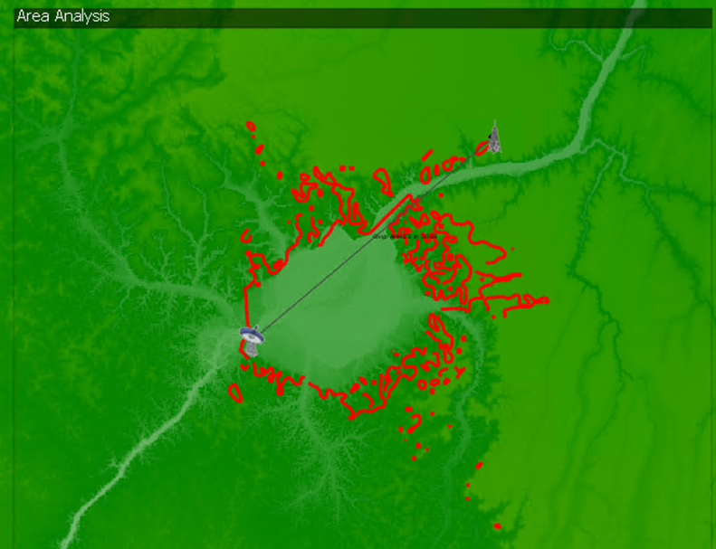
Figure 1: Area analysis with a I/N heat map around FSS ES.

The FSS earth station sites included in this study are currently operating FSS earth station antennas along with the satellite being tracked. A wide range of antenna sizes from 2.4-9.3m have been selected in the study to get a diverse set of results. These antenna sizes represent actual deployed FSS earth station antennas in these locations.

For different regions, the results vary mainly due to the following factors
- ES pointing/ Elevation
- Antenna size
- Terrain

Usually at lower elevation angles, received interference is greater as compared to higher elevation angles. However, that is only one factor. Antenna size makes a big difference as well. Smaller antenna means wider beam width, hence more interference whereas bigger antenna means narrow beam width and less interference. Terrain plays the most significant role in determining the exclusion zone. A flat terrain would have widespread exclusion zones as compared to a rocky terrain and mountains with a lot of obstructions making line of sight more unlikely and resulting in higher propagation loss.

In this study, 4 cities are selected based on population, geographical significance and FSS deployment in 3 600-3 800 MHz.

The results summarized below are I/N heat maps. Red contour represents an I/N of -10 dB for Mobile parameters and yellow contour represents results for Mobile parameters. The blue circle is the required separation distance needed in each case.

Part C: Current Status of Band
Currently under Article 5 of Radio Regulations, in the 3 600-3 800 MHz band, Mobile Service (MS) has an allocation on a secondary basis in Region 1. WRC-23 Agenda Item 1.3 addresses studies on a possible upgrade of the MS to co-primary. Such upgrade should only be considered under conditions that fully protect the existing primary services in the same and adjacent bands.
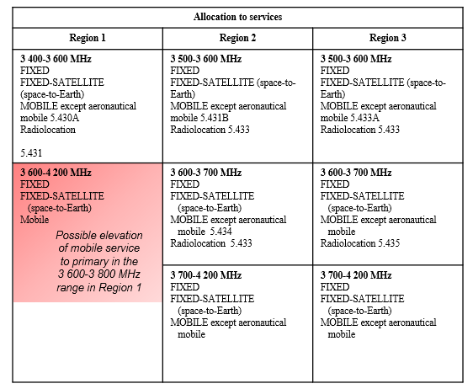

The purpose of this sharing study is to analyze possible co-existence between FSS and Mobile systems on a co-primary basis and determine the impact from Mobile on FSS receivers and the exclusion zones required to shield from harmful interference.

Part D: Conclusion of the results of studies, if any

Results
A wide range of antenna sizes from 2.4-9.3 m have been included in the study to get a diverse set of results. These antenna sizes represent actual deployed FSS earth station antennas in these locations.

For different regions, the results vary mainly due to the following factors
- ES pointing/ Elevation
- Antenna size
- Terrain

Usually at lower elevation angles, received interference is greater as compared to higher elevation angles. However, that is only one factor. Antenna size makes a big difference as well. Smaller antenna means wider beam width, hence more interference whereas bigger antenna means narrow beam width and less interference. Terrain plays the most significant role in determining the exclusion zone. A flat terrain would have widespread exclusion zones as compared to a rocky terrain and mountains with a lot of obstructions making line of sight more unlikely and resulting in higher propagation loss.

In this study, 4 cities are selected based on population, geographical significance and FSS deployment in 3 600-3 800 MHz.

The results summarized below are I/N heat maps. Red contour represents an I/N of -10 dB for Mobile parameters and yellow contour represents results for Mobile parameters. The blue circle is the required separation distance needed in each case.

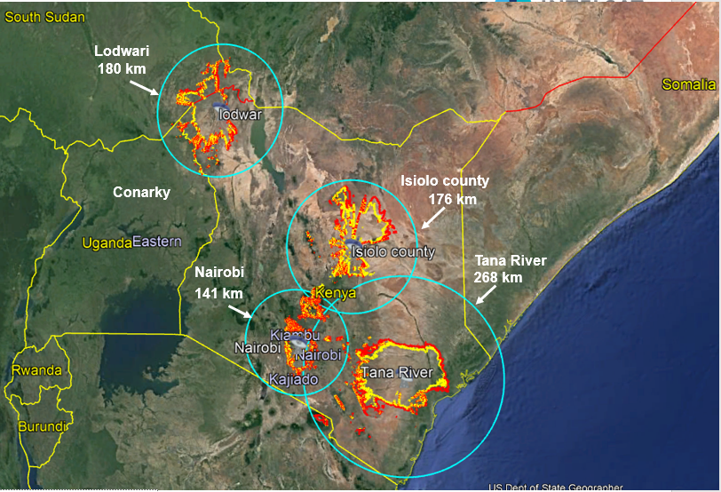
Figure 2: Google earth result for all cities in Kenya.

City | Antenna size (m) | Satellite | Elevation | Separation distance (km)
 |  |  |  | MS1 | MS2
Lodwar | 2.4 | IS 22 (72.1 E) | 46.7 ° | 180 | 178
Isiolo County | 3.7 | IS 22 (72.1 E) | 50.7° | 176 | 176
Nairobi | 9.3 | IS 37e (18W) | 27.3° | 141 | 141
Tana River | 3.8 | IS 39 (61.95 E) | 63.5° | 268 | 248
Table 5: Summary of separation distances per site.

Comparison to the existing ITU-R studies
Based on the single-entry analysis of 4 sites across Kenya, it is shown that the separation distances could vary from 141 km to 268 km depending on the terrain, antenna size and actual FSS receiver characteristics, such as antenna size and elevation angle.
The results of these studies indicate that in some cases significantly larger separation distances would be required than those indicated in the sharing studies in Report ITU-R S.2368 and Report ITU-R M.2109. Especially earth stations located in Tana River would receive interference from a Mobile BS over very large distances due to the flat terrain profile.

All results in this study are based on interference caused by a single Mobile macro-BS and the aggregate impact of other services or the full Mobile deployment has not been considered. Taking into account these aspects would increase the required separation distance.

Moreover, due to sensitivity of FSS receivers resulting in large separation distances, a regulatory framework is required to protect Earth stations in areas close to borders from potential interference arising from Mobile deployment in neighbouring countries.

Additional studies will need to be conducted to determine the impact of the Mobile out-of-band emissions to the FSS operations above 3 800 MHz, and in case of FSS earth stations that are deployed in a typical ubiquitous manner or with no individual licensing.

Part E: Options and Associated Implications
To be determined
Part F: Proposed African Common View and/or Position
Additional studies are required to include more administrations and to assess aggregate and adjacent band interferences

Part G: Recommendations and Way Forward
Administrations are encouraged to participate in the ongoing studies with the intent of positively influencing the outcome of the studies and contribute to the studies of WG5A as much as possible.

Additional studies to address the following:
- Short-term interference from MS into FSS ES, with short-term criterion of the FSS;
- Aggregate interference from a full MS deployment;
- Separation distances required to protect FSS earth stations operating in known locations in frequency band above 3 800 MHz;
- Out-of-band emission limits or frequency separation required to protect FSS earth stations deployed in a typical ubiquitous manner or with no individual licensing.

The MS characteristics are developed in ITU-R WP 5A. The most recent MS characteristics are reflected in Annex 18 to WP 5A Chairman’s Report from the meeting held 28 April-11 May 2021 available at: https://www.itu.int/dms_pub/itu-r/md/19/wp5a/c/R19-WP5A-C-0359!N18!MSW-E.docx
Document 5A/589 Annex 18, available at https://www.itu.int/dms_pub/itu-r/md/19/wp5a/c/R19-WP5A-C-0359!N18!MSW-E.docx

